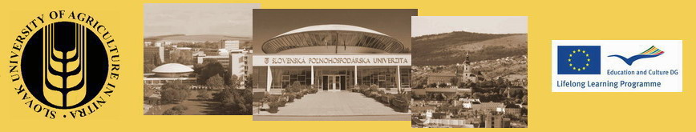
Travel Details - Teachers
LLP ERASMUS INTENSIVE PROGRAMME
Ecological production systems for environmental and human health (EPSEN)

Please return until May 31, 2013 to:
ipepsen2013@gmail.com

Name:
Arrival to Nitra, Slovak Republic:
Departure from Nitra, Slovak Republic:

Means of travel: bus train plane car

Travel cost refunds rules:
Real travel cost will be refunded after the Intensive Program, only upon sending the originals of bus ticket /train ticket / plane ticket+ boarding passes. If there is not the full price given on the ticket the original invoice, payment of invoice with stamp will be required too.

In case of traveling by car the costs can be refunded in the price of bus or train ticket (single or return) upon sending a written confirmation of the price of the ticket (single or return) issued by the bus company/ railways / travel agency with stamp and signature.

Participants have to use the most economic means of transport. Indicated travel costs that can be refunded according to project budget are:

Country of origin | Travel costs (EUR/person)
Czech Republic | 80
Poland | 280
Hungary | 100
Austria | 120
Latvia | 400
Estonia | 550
France | 500
Slovenia | 400

